Mapping Australia’s Landforms
Using an atlas, name (and colour where appropriate) the following landforms. Use an atlas to help you.
RANGES: Great Dividing, Carnarvon, Musgrave, Macdonnell, Davenport, Flinders, Grey, Hamersley, Robinson
MOUNTAINS: Kosciuszko, Bartle Frere, Ossa, Uluru, Woodroffe
DESERTS: Great Victoria, Great Sandy, Simpson, Tanami, Gibson, Sturt Stony
COASTAL: North West Cape, Cape York, Cape Howe, Cape Byron, Moreton Bay, Esperance Bay, Kangaroo Island, Point d’Entrecasteaux, Exmouth Gulf, Spencer Gulf, Limmen Bight, Great Australian Bight, Gove Peninsula, Bass Strait
RIVERS: De Grey, Lachlan, Darling, Daly, Murray, Condamine, Leichhardt, Murchison, Diamantina, Cooper Creek
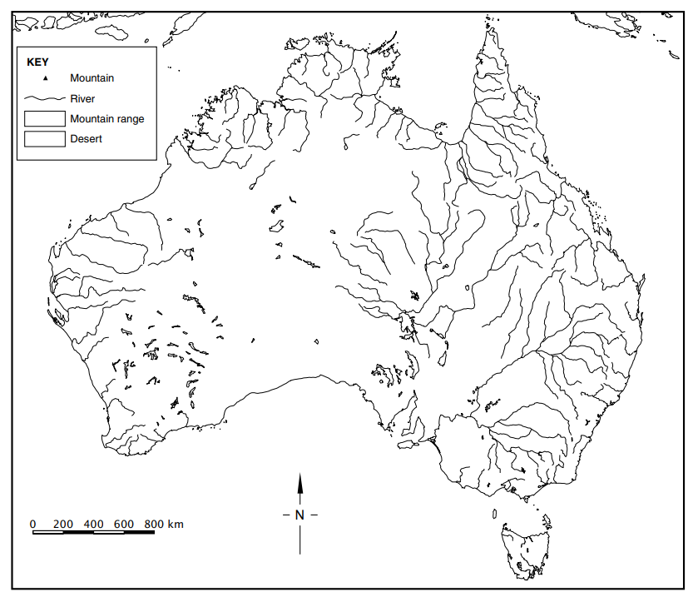
LAKES: Eyre, Pedder, Mackay, Torrens, Disappointment, Carey, Gairdner, Austin, Amadeus, Frome, Barlee

